# **Experiment No: 1**

| **Experiment No 1**  **1: Installation and Configuration of Flutter Environment.** | |
| --- | --- |
| **ROLL NO** | **46** |
| **NAME** | **Amit Nayak** |
| **CLASS** | **D15-B** |
| **SUBJECT** | **MAD & PWA Lab** |
| **LO-MAPPED** |  |

# 

# 

**Experiment 1**

**Aim**: Installation and Configuration of Flutter Environment.

**Theory:**

Flutter, an open-source UI software development framework crafted by Google, facilitates cross-platform application development, enabling the creation of apps for both iOS and Android with a single codebase. Built on the Dart programming language, Flutter emphasizes the use of widgets as fundamental UI elements, allowing developers to compose intricate user interfaces. Its standout feature, Hot Reload, enables real-time visualization of code changes during development without restarting the application. Flutter supports both Material Design and Cupertino style, offering a rich set of customizable widgets for versatile design. Known for high performance, Flutter compiles to native ARM code, contributing to its efficiency. The framework's active community contributes to its ecosystem with packages and plugins. Flutter's appeal lies in its streamlined development process, expressive UI, and the ability to maintain a single codebase, making it increasingly popular among mobile app developers.

**Installation:**

1. Install Flutter sdk

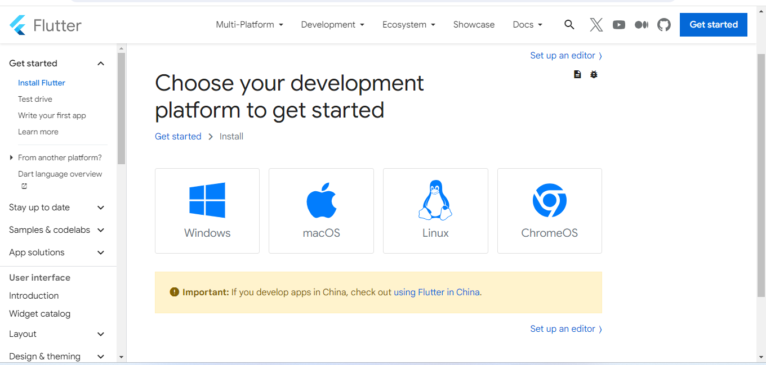

1. Install Android Studio

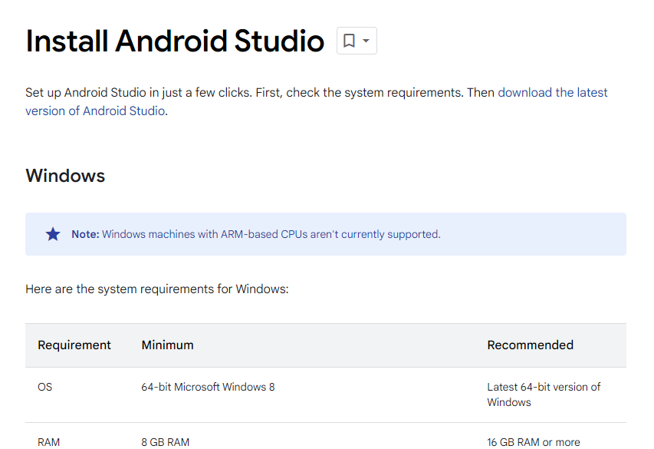

3)Setup Android Studio

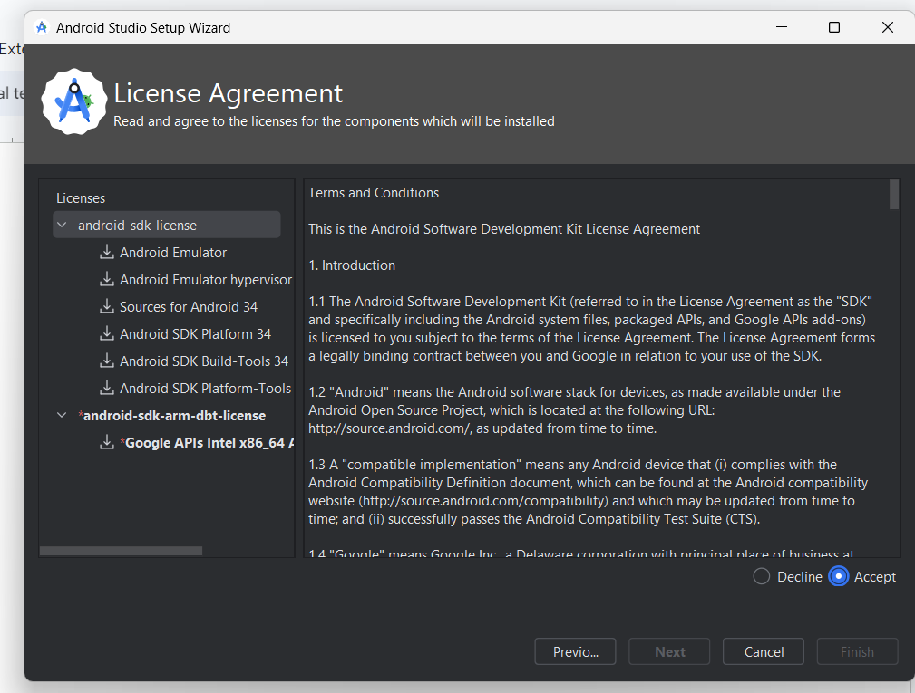

4) Update the environment variables

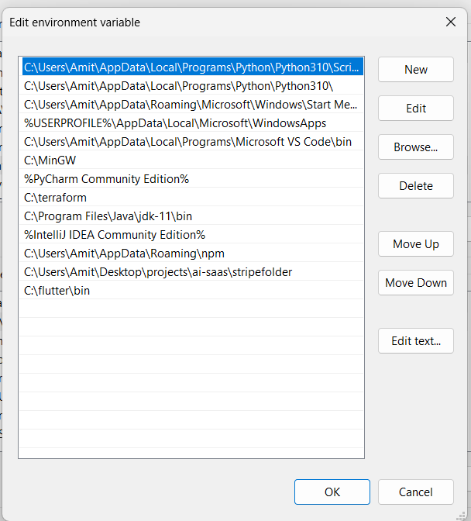

5)Check if flutter is installed by typing flutter in command prompt

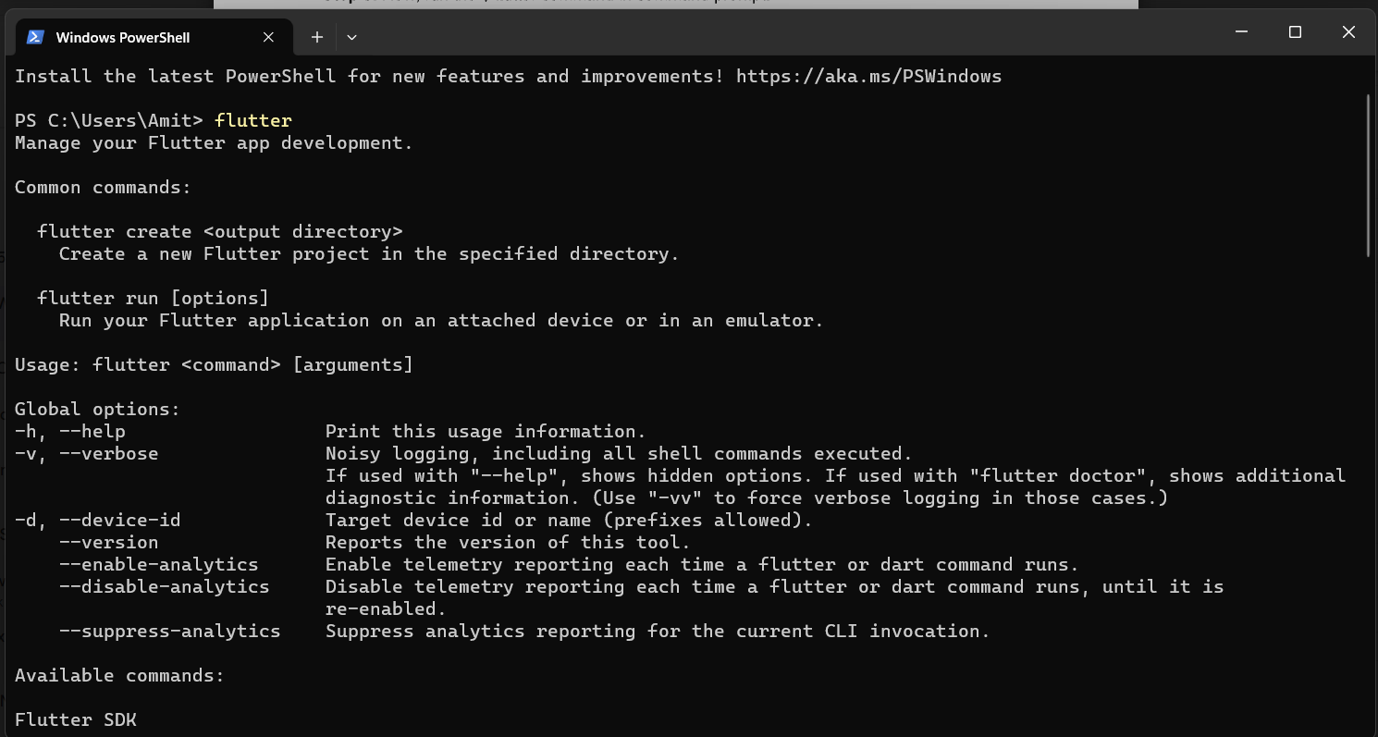

6)Run flutter doctor command

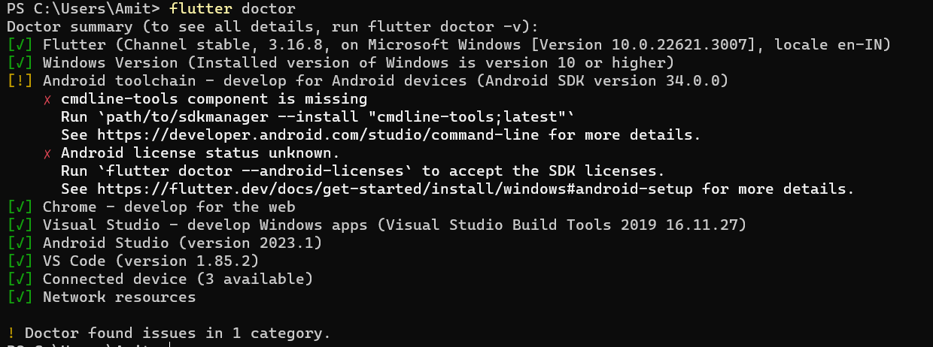

7)Open Android Studio

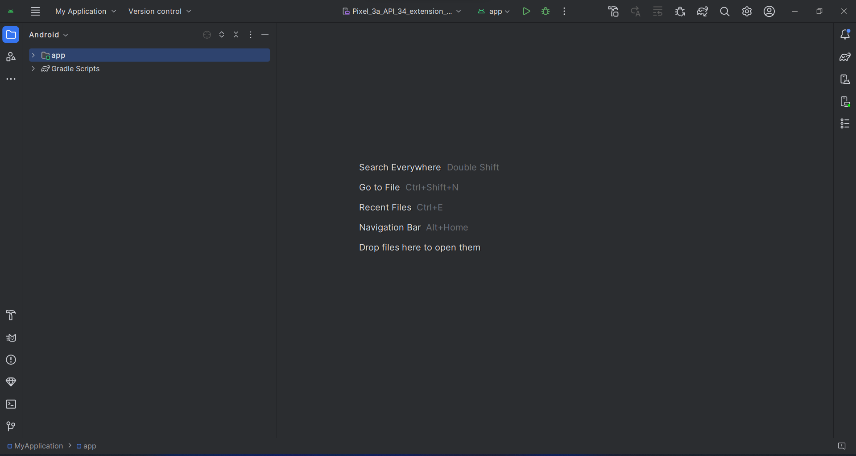

8) Select Hardware

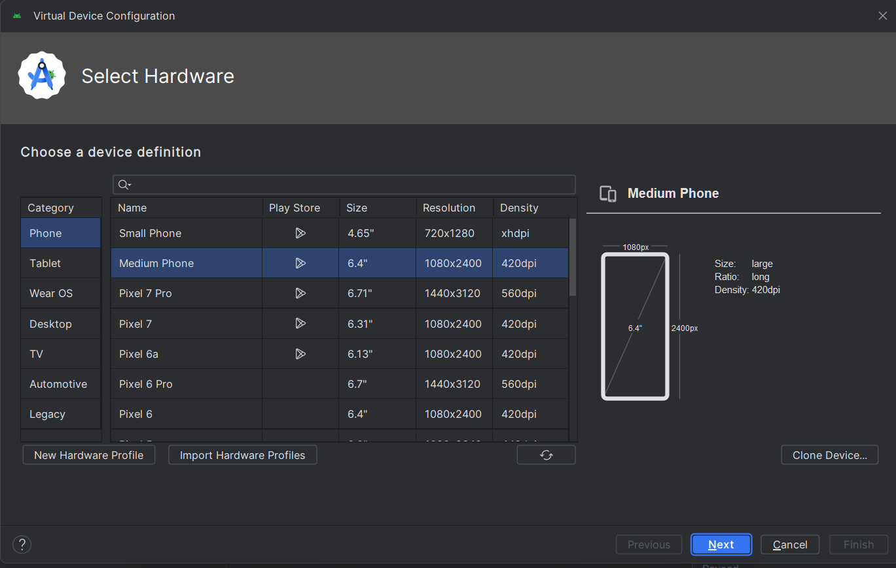

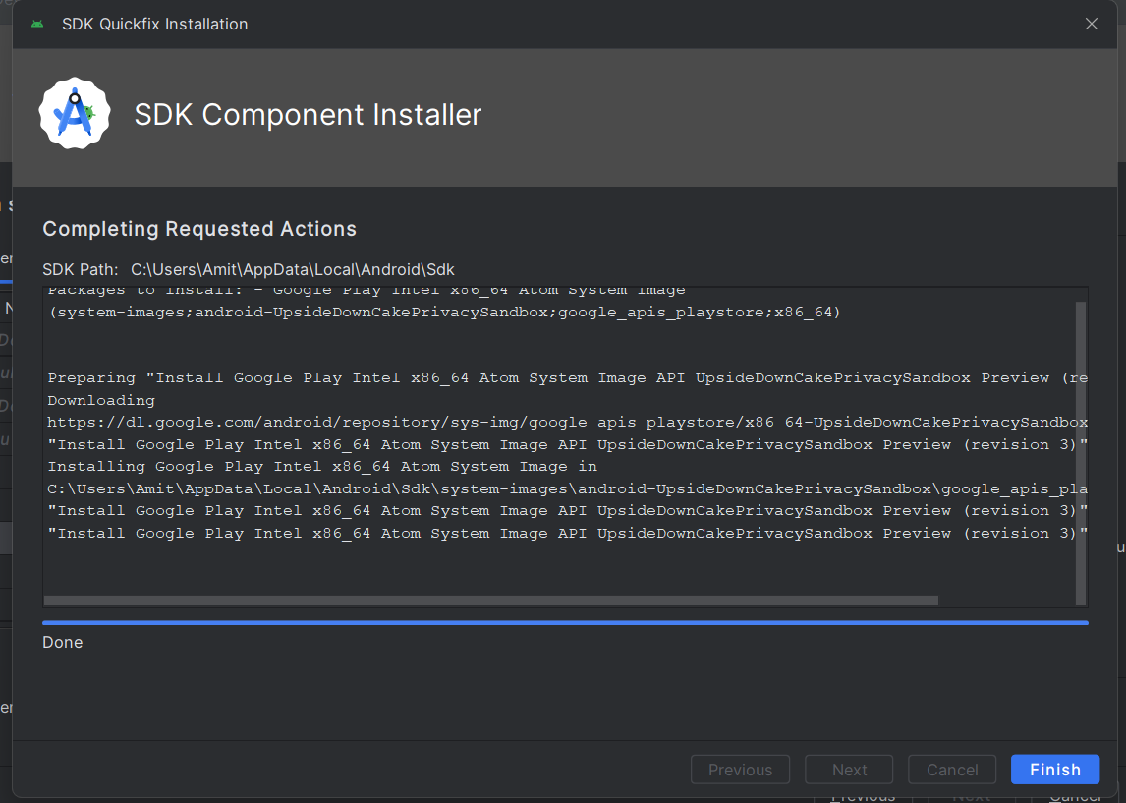

9) Install and setup device

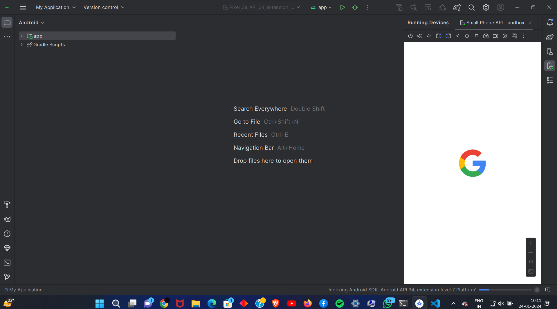

10) Install dart and flutter plugins

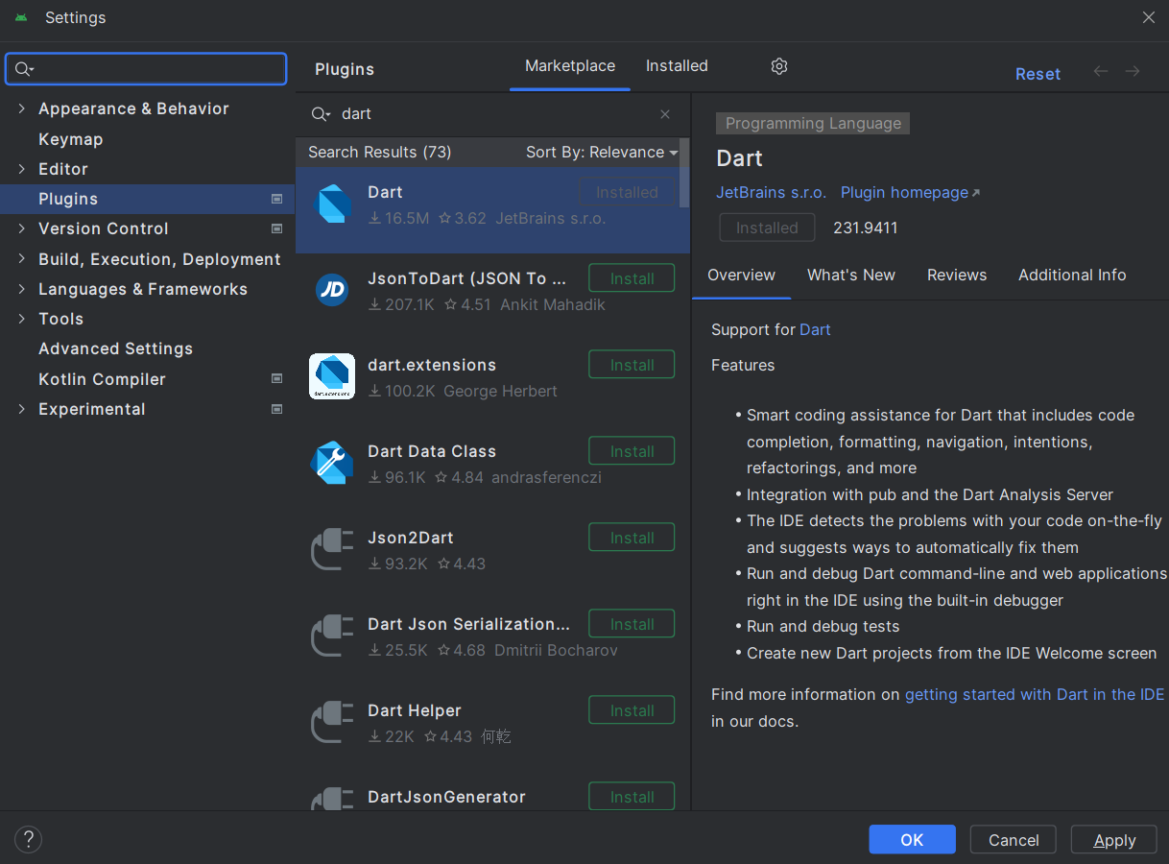

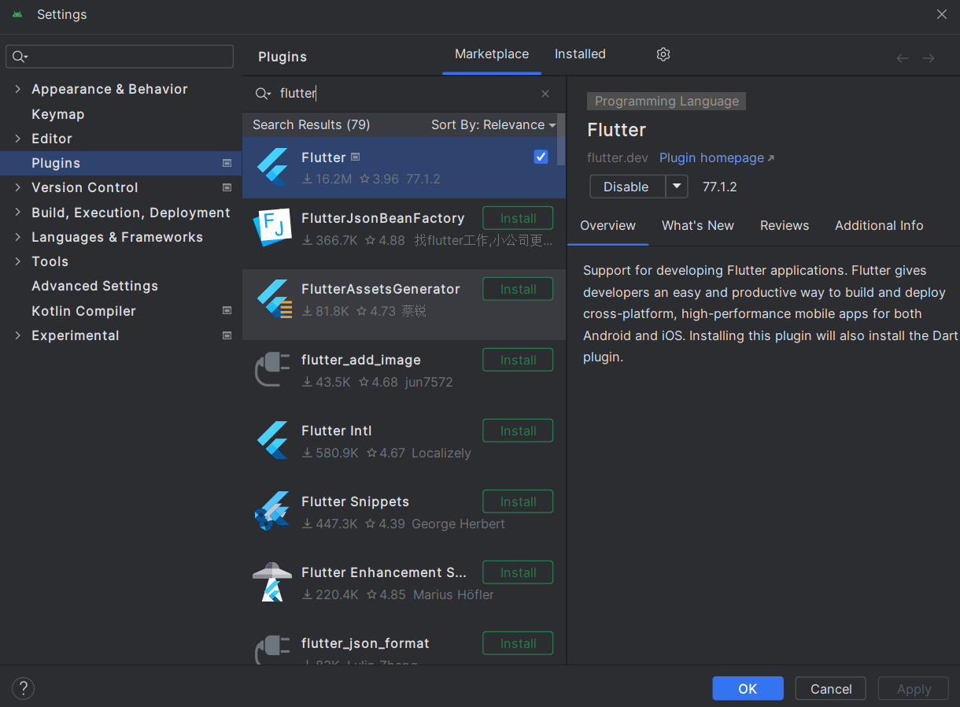

11) Restart Android Studio

**Conclusion:** We have successfully configured and installed Flutter environment